

MACY*S

**STRATEGY PROPOSAL**

**OF DEPARTMENT STORE**



**HUNTSVILLE**

d

***Team 9: Yinchen Li, Lan Zou, Jiemin Huang, Xian Zhang, Hongdi Zhang***

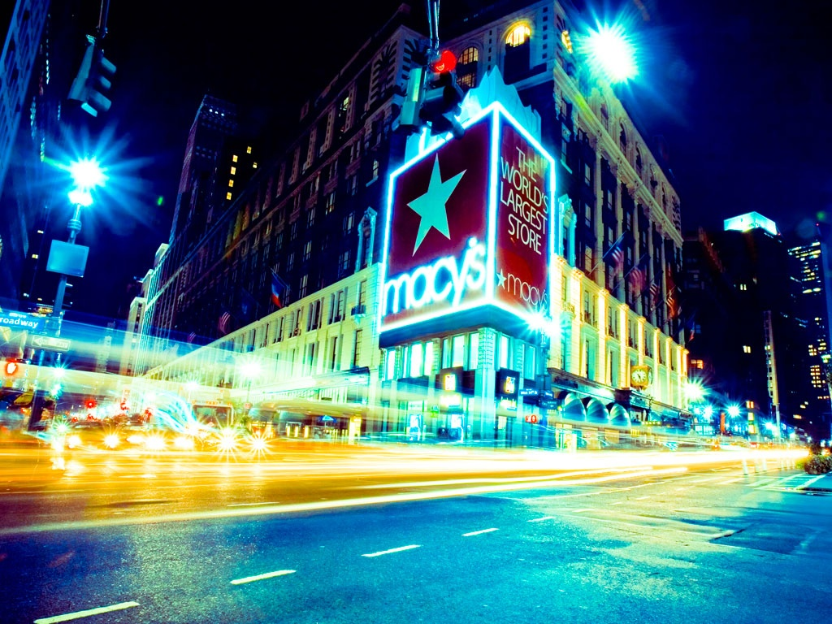

***6***

***15***

***22***

***30***

***32***

**STRATEGY**

**RETURN ON INVESTMENT**

**REFERENCE**

**INTRODUCTION**

**COMPETITIVE ANALYSIS**

**ASSESSMENT**

***4***

***6***

***15***

TABLE OF

**CONTENTS**

***Report 2018***



**HUNT SVILLE**

2

3



INTRODUCTION

**HUNT SVILLE**

# BACKGROUND

***Macy’s Inc.***

4

5

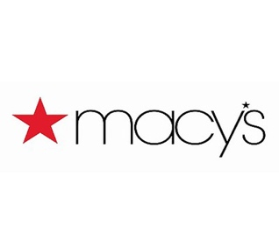

Future Retail in 10 Years

As Forbes mentioned about retail industries in the next ten years, “consutainment” is introduced as the combination of consumer, ultra-fast delivery, and entertainment.

Ultra-fast Delivery

The current norm about online shopping delivery is tow-day. However, about 25% consumers stated that they will reconsider the order if one-day delivery is not offered. Farfetch, a luxury fashion department store, provides a 90-min delivery on New York State right now. It will not be surprised that two-hour drone delivery will happen in the foreseeable future.

IoT-powered Auto Shopping

The pantry will make the order automatically for clients. Revolutional container will sense inventory levels and refresh the items without even a click. Clients will not have to keep eyes on pet foods, coffee, or snacks to refill the produce; instead the smart container literally order the item for clients.

Digital Dressing Room

The future dressing experience is like acting in the movie. Stores host unique, theme-driven interactive experiences. The dressing mirror is able to adjust to different color and sizes with 3D version on fitting and suggestion on looks.

Robot Consumer Service

On the research of LoweBot, about 67% clients prefer self-services instead of traditional in-store shopping. Robots may offer a help by speaking multiple languages, finding items, as well as security guards. Otherwise, personalization and customization are two focus point.

Physicial stores occupied in 1858 and in 2016

Department Store provides diversity good and product for retail sales, under different brand and management. Usually department store is a large retail establishment that offer a wide variety of good into separate department in multiple locations, typically including clothing for men, women and kids, jewelry and accessories, belts and scarves, shoes, and cosmetics. Some retailers, such as Macy*s, also provides small number of electrons, sports equipment, toys and furniture.

Macy*s was founded in 1858 and becomes the top 10 largest department store for couple decades with about 670 local store covered the whole United States, is an American department store chain owned by Macy’s Inc.  In 2016, Macy*s division operates only about 667 store compared to 870 store twenty years ago. In 2015, Macy*s is the biggest largest US department store by retail sale, and 15th largest by revenue. This store has tremendous development in the traditional legacy retail areas, currently focus more on e-commerce-focused business to see growth opportunities on their core business, and cut off their cost for healthy Enterprise Resource Planning (ERP).

Ranking globally

**34th**.

FY15 e-commerce growth rate

**37.8**%

**3,100mn**

$: 2015 e-commerce Retail Revenue in USD millions

Macy*s Ecommerce

Statistics

**870**vs**667**

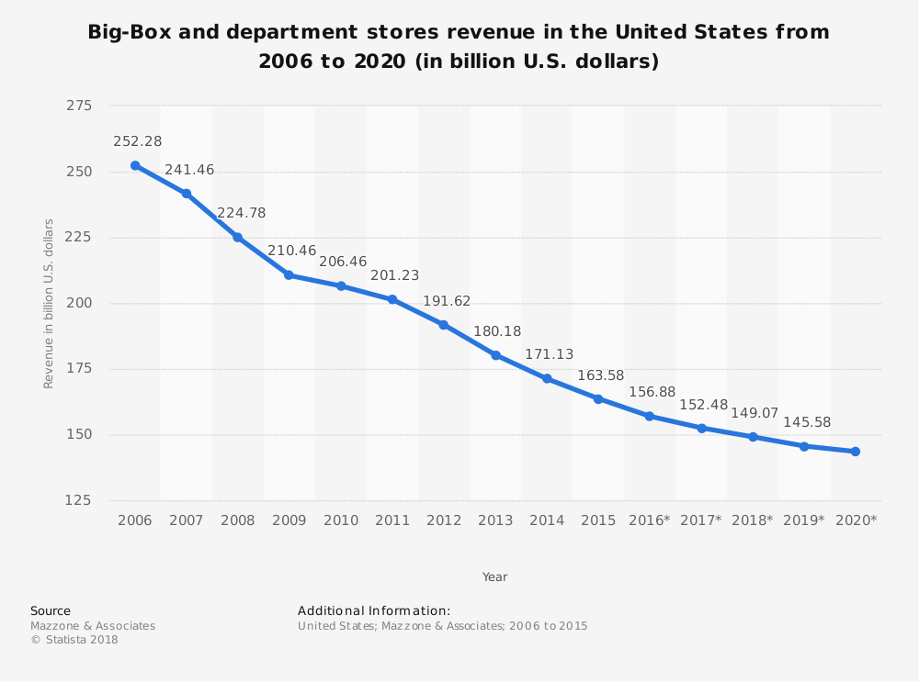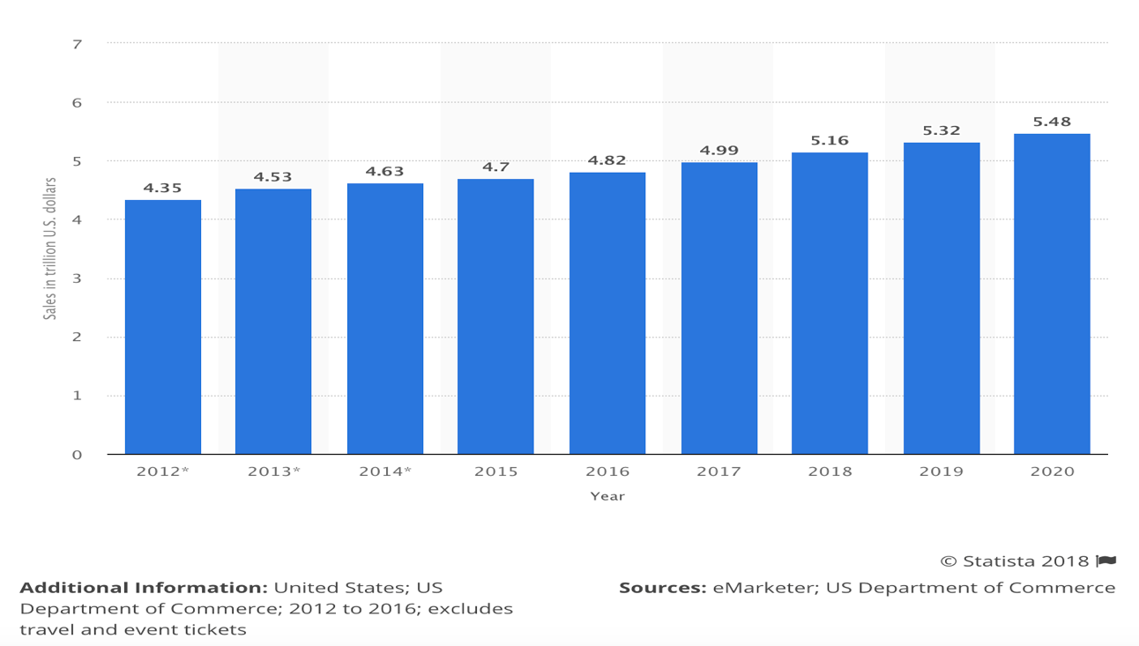

Trend of Departmental Stores

Trend of Departmental Stores

COMPANY

**HUNT SVILLE**

**COMPETITIVE ANALYSIS**

***Macy*s Inc.***

9000

8000

7000

6000

5000

4000

3000

2000

1000

0

***One***

***33.33%*** *One*

***Two***

***Three***

***33.33%*** *Three*

***JAN***

***FEB***

***MAR***

***APR***

***MAY***

***JUN***

***JUI***

***AUG***

***SEP***

***OCT***

***NOV***

***DEC***

***Fig. 3***

***33.33%*** *Two*

***754***

***593***

***342***

***227***

***354***

***528***

***601***

***197***

***256***

***225***

2016

2015

2014

2013

2012

2011

2010

2009

2008

2007

6

7

Despite the prediction that consumers in the U.S. will continue to spend more dollars on retails (see figure 2.1), the industry of departmental stores, which was believed to be the brick-and-mortar player in the retail market, has been steadily declining over the past few years (see figure 2.2) due to the maturity of e-commerce retailers such as Amazon.com

Trend of departmental stores

In this fierce competition with online e-commerce and other departmental stores, Macy’s has positioned itself as the head of departmental stores of apparels and initiated omni-channel strategies but much of the focus has been put on discounts and holiday sales of apparels. Meanwhile, Amazon.com’ s development of prime members, customer preference recommendation, and the fast fulfillment services has been changing the shopping habits of consumers, making every shopping step fast and smooth.

Left: Figure 2.1 Total retail sales in the United States from 2012 to 2020 (in trillion U.S. dollars)

The timeline presents total retail sales in the United States from 2012 to 2020. Total retail sales in 2020 are projected to amount to 5.48 trillion U.S. dollars, up from 4.35 trillion U.S. dollars in 2012.

Right: Figure 2.2 Big-box and departmental revenue in U.S. from 2006 to 2020

In this section, we will compare Macy’s with its major competitor Nordstrom, and its major threat in the e-commerce age, Amazon.com, to explore the future potential opportunities and to provide the reliable evidences for our proposed strategies. To make the content concise and comprehensive, our comparison will focus more on dimensions of innovative moves to boost client traffic and revenue, but will focus less on new partnerships, acquisitions, marketing strategies, and other dimensions which were traditionally dimensions of competitive analysis.

According to a study from Coresight Research, 42% of the consumers who reported spending less with Macy's on apparel in the last three years said they moved that spending to Amazon, which was more than any other retailer.

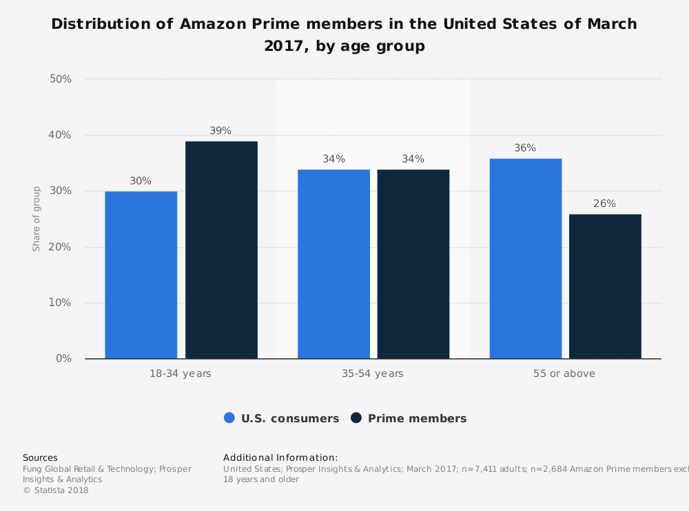 

Figure 2.3 Distribution of Amazon Prime Member in the US

#2 — Nordstrom

#3 — Macy‘s

Nordstrom, Inc., incorporated on September 28, 1946, is a fashion specialty retailer in the United States. The Company's segments include Retail and Credit. As of March 20, 2017, the Company operated 344 the United States stores located in 40 states as well as an e-commerce business through Nordstrom.com, Nordstromrack.com/HauteLook and TrunkClub.com. As of January 28, 2017, the Company operated approximately three Nordstrom full-line stores, including two in Canada, and 21 Nordstrom Rack stores. The Company also offers its customers a variety of payment products and services, including credit and debit cards.

Macy's, Inc., incorporated on December 13, 1985, is an omnichannel retail company operating stores, Websites and mobile applications under various brands, such as Macy's, Bloomingdale's and Bluemercury. The Company sells a range of merchandise, including apparel and accessories (men's, women's and children's), cosmetics, home furnishings and other consumer goods. The Company's subsidiaries provide various support functions to its retail operations on an integrated, company-wide basis. As of January 28, 2017, the operations of the Company included 829 stores in 45 states, the District of Columbia, Puerto Rico and Guam, comprising a total of approximately 130 million square feet.

Amazon.com, Inc., incorporated on May 28, 1996, offers a range of products and services through its Websites. The Company operates through three segments: North America, International and Amazon Web Services (AWS). The Company's North America segment primarily consists of retail sales of consumer products (including from sellers) and subscriptions through North America-focused Websites, such as www.amazon.com, www.amazon.ca and www.amazon.com.mx. The North America segment includes export sales from its North America-focused Websites

Macy’s has a wide customer base, with almost 50% of the all the customers shopping at Macy’s last year. To maintain and grow this customer base, Macy’s has conducted Brand Tracking researches to identify their customers. Top purchased categories are women’s apparel, men’s apparel, and women shoes. 70% of their customers are female while only 30% are males (2017 MBA challenge). A typical customer of Macy’s will love the experience of shopping, seek the brand names, pay a little more than fair price for quality offered. The struggling experience of Macy’s typical customers is the chaos of department stores and online, poor guidance, cheap feeling of apparels. To explore the customers by age, Macy’s is targeting at the American middle class who prefer quality products at reasonable prices. Those customers also include Millennials, which are the major drivers of the digital transformation to online and mobile shopping. Loyalty program it offers, namely star rewards program, brings benefits to consumers with cash back, free shipping online and other exclusive discounts both online and offline. The main driven factor of this loyalty program is low pricing and seasonal discounts. Loyalty status is determined by customer’s expenditure.

The primary age range of Nordstrom is between 14-34, younger than Macy’s primary shopper (25-44).  Within this age group, the targeted group of Nordstrom is focusing on mostly high-end shoppers. However, the company’s Nordstrom Rack stores target middle-class consumers and compete with Macy’s business (not including Bloomingdales). The popularity of Nordstrom Rack stores has been boosting the company’s growth in recent years. Nordstrom is also attracting Millennials, which is what Macy’s is target at as well. They tried hard on improving customers’ in-store experience and trained sales associates to be more attentive and welcoming to the customers in their store. Nordstrom loyalty program offers credit card program to its customers, somewhat similar to Macy’s strategy. Additionally, management indicated that kid’s and men’s apparel were the top selling categories in the final quarter of the year.

Amazon.com Inc’s targeted customer group is more of a mystery topic to dig in deeper. Average age of amazon consumers are 37 years old. The demographic layout provided by Fung Global Retail & Technology has shown that it attracted prime members from all age groups (see Figure 2.3) Most of them are within the age of 18-54, which made no restriction of the products they can sell. According to a survey done by Coresight research, the growth of apparel of Amazon is also predicted to be very optimistic, given that prime members remains loyal and number of brands offered on Amazon continues to be enlarged. The unique experience of Amazon’s customers are customized fast two-day delivery due to the great fulfillment structure, recommendation online thanks to the big-data technology, and lowering the price with flexible tax rate.

Target customers and current customers

*Reuters Company Profiles*

Overview and Profiles

**COMPETITIVE ANALYSIS**

***Macy*s Inc.***

COMPANY

**HUNT SVILLE**

#1 — Amazon.com Inc EXPERTISE

8

9

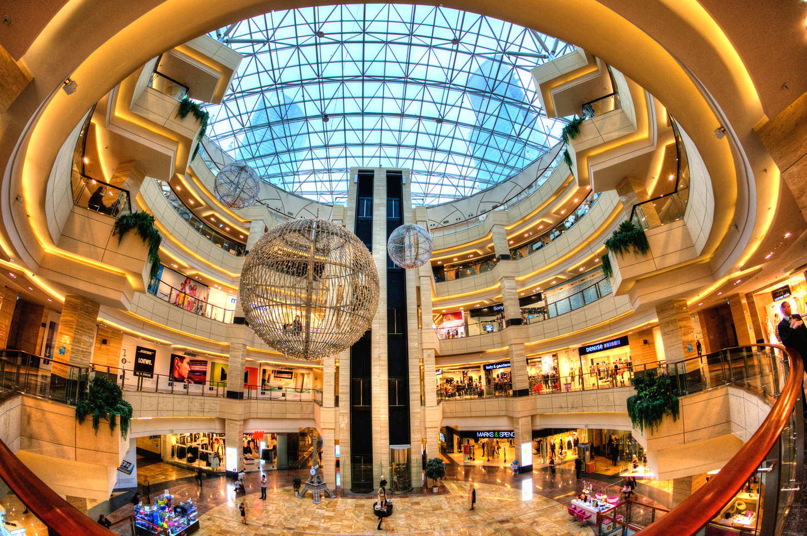

ACTIVITY

10

11

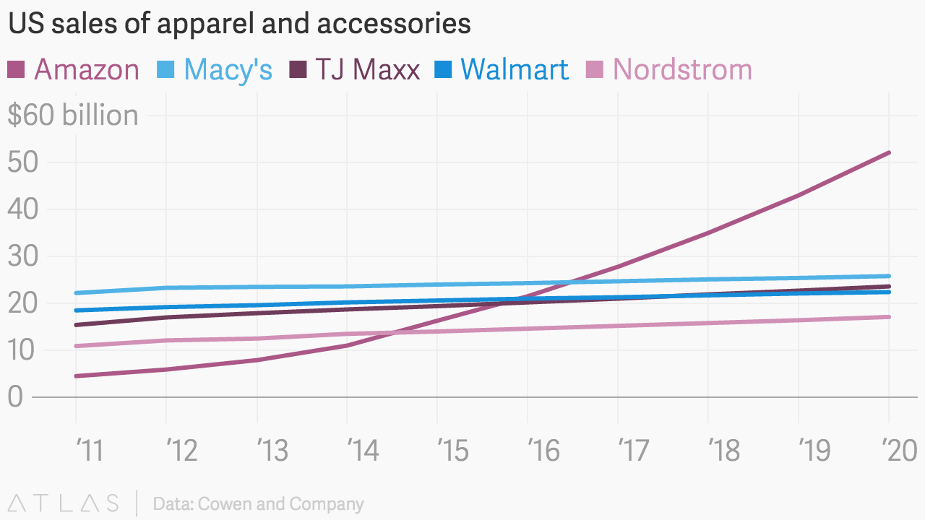

**Macy’s**

* Macy’s Systems and Technology, Inc. engages in creating, gathering, and directing pieces of data to form management tools. The company provides integrated retail, e-commerce, and data warehouse systems. It also offers a range of services from advanced in-store register systems to sophisticated data management to the burgeoning online marketplace.
* Using stores to fill online orders or orders from other stores, as well as offering customers the option of ordering online before coming in stores.
* RFID technologies to support supply chain.

**COMPETITIVE ANALYSIS**

***Macy*s Inc.***

**Amazon**

* Amazon announced its new augmented reality (AR) mobile app for iOS, it stressed visual issues and allowed shoppers "to make sure a desired product fits their style and aesthetic."
* Amazon is continuously optimizing itself and is highly customer-focused. It uses machine learning algorithms on the huge amount of web data generated by customers to look for the trends and personalized preferences, and, based on that, it re-configures its processes and services for customers.
* In order to capitalize, Amazon is developing Prime Wardrobe, an apparel service exclusive to prime subscribers. The service, which is still being tested but has been rolled out to more consumers, allows subscribers to order up to eight apparel items at a time, send back what they don't like, and only pay for what they keep, all for free with a Prime account.

**Nordstrom**

* Nordstrom offers mobile feature that gives customers the ability to reserve merchandise online and try on in stores in 2017.
* Acquired Bevyup, which provides an integrated mobile app that will strengthen sales associates’ relationships with customers beyond the physical store.
* Nordstrom Innovation Lab constantly exploring new technology to adapt to Nordstrom’s retail business.
* New Nordstrom local stores that only accept online order pickup, alternation, returns and fast delivery.

Current innovative moves to boost customer traffic

COMPANY

12

13

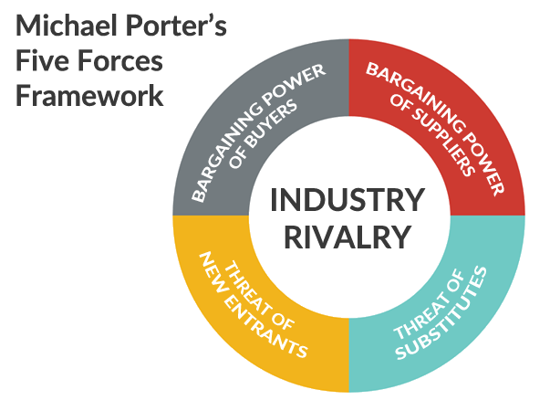

Figure 2.4 Porter’s Five Forces Model

The number of suppliers of Macy’s is enormous. Available suppliers in the market, including footwear, apparels, homewares and furniture, are various in both brands and numbers. Price drop of a specific product in the market might leads to the price changes among most suppliers. Therefore, Macy’s has free choice of suppliers and the bargaining power of suppliers are low.

**Weak Bargaining Power of Suppliers**

Given that customers now have more choices online and offline. A report has indicated that 42% of the consumers who reported spending less with Macy's on apparel in the last three years said they moved that spending to Amazon, which was more than any other retailer. Meanwhile, retail industry is in rapid change. Department stores are designing more events & experiences to attract customers. For instance, some Nordstrom stores are upping their investment in the restaurant in store, hoping to become a destination on its own that then spills over into store browsing.

The intensity of competitive rivalry is strong in the retail industry Macy’s is in. Number of competitors are enormous, and the variety of competitors just adds more to the competition. While Macy’s is currently one of the industry leaders, remaining the top position and retaining customers are still a harsh job for Macy’s.

Department stores are not a easy task to start. Macy’s has built its worldwide footprints for over 100 years, and the number of new entrants and qualities are limited. As a result, the threat of new entrants is low.

**Medium Bargaining Power of Buyers**

***Leading the industry***

The large population of buyers exerts a strong force on Macy’s and the retail industry. However, the weak force of buyer diversity and the weak force of small individual purchases counteract such condition. The large population of buyers makes it difficult for them to impose significant pressure on retail firms like Macy’s. However, now customer’s experience is one of the main concerns of department stores. Additionally, Macy’s is facing the threat of losing customers to competitors like Amazon and other department stores. Therefore, the bargaining power of buyers for Macy’s is in the middle.

**Weak threat of New Entrants**

**Strong Industry Rivalry**

**Strong threat of Substitutes**

Porter’s Five Forces Model

**COMPETITIVE ANALYSIS**

***Macy*s Inc.***



ASSESSMENT

**HUNT SVILLE**

***Macy*s Inc.***

14

15

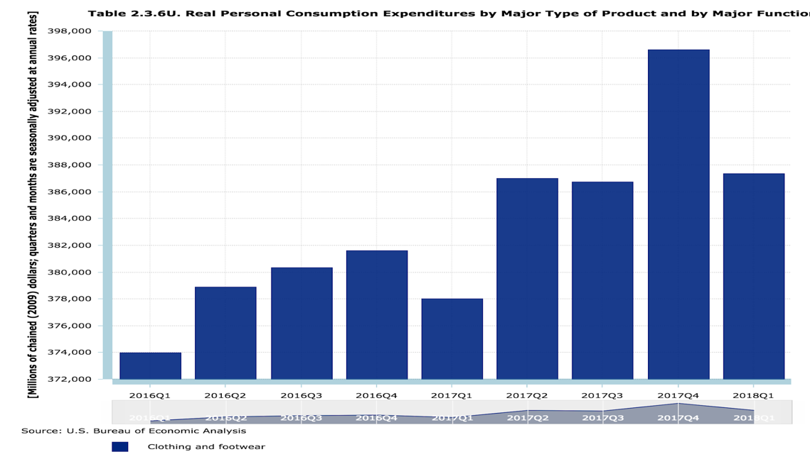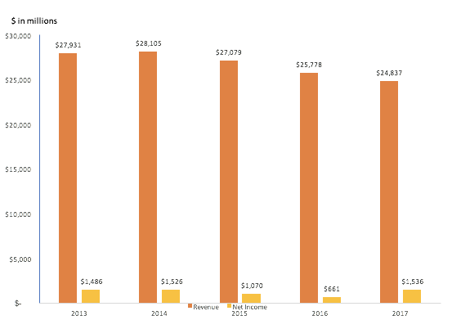

Left: Figure 3.1 Historical 5 Year Financial Performance - Macy’s

Right: Figure 3.2 Personal Consumption by Clothing and Footwear

$

**Issues**

**- 3,094 MM REVENUE**

As mentioned earlier in this report, Macy’s has been a leading retailers in the market for decades. Nevertheless, it has been losing its earning power recently. Several signes has indicated it:

* Decreasing revenue
* Slower inventory turnover
* Declining store traffic

It has been reported in Macy’s fiscal report that its primary business lines consist of  a)Women’s Accessories, Intimate Apparel, Shoes, Cosmetics and Fragrances, b)Women’s Apparel c)Men’s and Children’s. These business segments has contributed 38%, 23% 23% of the revenue, respectively, and the mix have been stable for the past few years. While Macy’s is in a trend of going down, the economy, however, has indicated a different direction. Multiple indicators has shown that the US economy has recovered entirely. Among all these facts, the most convincing evidence comes from the following chart,  the US consumer’s expenditure on footwear and clothing has been continuously increasing from Q1 2015 through Q4 2017, from $382 billion to $405 billion.

This has reveals that the macro economy might not be a contributing factor towards Macy’s slack sales. A further study is needed to understand the causes of it.

The shopping behavior of Macy’s primary target customers has changed dramatically. Macy’s has been targeting consumers with age from 25 to 44, who are the future of the spending power. These generations are known to be savvy with technology and continues to migrate to online shopping, for the benefit of convenience.

Despite the heavy investment on its e-Commerce department in these recent years, Macy’s was still outperformed by its online competitors, such as Amazon. One of the example is the timeliness of fulfillment. Currently, Macy’s standard shipping takes 3 to 6 business days, which is apparently much slower than Amazon’s 2 days shipping and less favored. Because of that, Macy’s is incapable to meet its target customers’ expectation and therefore lose its customer base.

**01**



PROCESS

16

17



With tremendous researches and careful analyses of industry experts’ comments, we have summarized the causes as follows:

**Causes**



**02**

**Lack of differentiation on its products**

ASSESSMENT

***Macy*s Inc.***

Left: Figure 3.3 Shipping Time Comparison between Macy’s and its competitor

Right: Figure 3.4 Product Comparison between Macy’s and its competitor

In addition to the consumers’ migration to digital platform, an even more serious problem should be aware of: Macy’s products are no longer attracting to its customers. Through multiple reports, experts has pointed out that there is nothing sets Macy’s apart from its competitors. It tends to sell run-of-mill products which shoppers can find and buy cheaply from somewhere else. Lack of differentiation has snapping Macy’s competence and eventually its profitability.

|  |  |
| --- | --- |
| Macy's Product | Competitor's Product |
| https://lh4.googleusercontent.com/AYfJf9CC4U5iLAOJYMwWPMEudE0lvWRl_tdh5VgzlsFATMe3-nV14DSBI8MO3xxtT_h0JzGf5OZ8fHX9n7R8Z_svg9YMlY0mASistXz_yWMo_s-mYQkjrZNP7AeA9-meWl5HloA8 | https://lh6.googleusercontent.com/S_NsLRbKSUYLbYjA84EnYhMuMXhTG8W1YuYaeyx4NBz7RIGwo7SSCXjcRQOdkARath4ZD0c6cvU9FyXa2HXeu42vZH4ACKkQ1xVfoBPhwbeUcHwfUr9p3la-7APoZSfZmRAaCEnh |

**Incapability to keep up with consumers’ behavioral change**

Furthermore, Macy’s target customer are very keen on new technology. They are more open to try something new and continuously adapt themselves to it. Eventually, stores implementing newer technologies are more likely to attract these customers.

|  |  |
| --- | --- |
| Macy's Shipping Time | Competitor’s Shipping Time |
| https://lh6.googleusercontent.com/HgnZ1FHD4XIF2Gs3ZwTo5NnN8DDDwYiF2GmPVpgy8gKa9borD6wd273fIVqpZv5s6cH3zCp6p9ONqPjc78fd6ABoz9LmRJS5zP8Yb7gk-9Xl4rY92xfOLT0Kh63o4gRBSCQ1Brlg | https://lh3.googleusercontent.com/ugah1ZOyA0Z6DIHWPhCs_6f51oaGw791hMJ9LBx7arztifdwpgQfrZvyXxO48Zn8oz8qxTb4wbnqoKRYccTBtmdiY2U2JqdRQauloUSdk5MiGKZu38Re25PJY5ynD9P_6-0P68KT |



PROCESS

18

19

ASSESSMENT

***Macy*s Inc.***

***Those*** [***department stores***](https://www.thebalancesmb.com/largest-us-retailers-4045123)***that have survived the decades did so by keeping pace with customer needs and preferences."***

***–Terry Lundgren, Robin Report***



**04**

**Weakening brand recognition**

As a century-old department store, Macy’s has a legacy of success amongst older generations. While the future of spending power is shifting to younger generation, Macy’s is losing its attraction because of older style products, off-the-pace shopping experience. As is shown in the previous chapter, current customer demographics shows that the majority customers are aged from 25 to 44, which substantially deviates from Macy’s target customer base, who are millennials aged from 14 to 25.



**03**

**Incapability to provide unique shopping experience**

Apart from the products themselves, newer generations of consumers are looking to better shopping experience as well. While shopping online is for the convenience, consumers shopping in-store nowadays are expecting something beyond ordinary. In order to compete with online commerce, a lot of traditional retail chain have made changes to meet the new expectation from the consumers. In this regard, Macy’s is in an urgent need of improving its shopping experiences.

Figure 3.5 Shopping Comparison between Macy’s and its competitor

|  |  |
| --- | --- |
| Macy's Shopping Experience | Competitor's Shopping Experience |
| https://lh5.googleusercontent.com/xA-hezpKjD_wZ_sPthKgfn3h6wbz9BL1yo2NsIFIBYAVqh1SWR_wUjSdMR1iAyaMXurKqGJLoPhP0KfME8YaWyUl-5YvOKPHSmVksJKO9X2qJb_mEL8lvwGnrUvm6r6sbYAgyFuI | https://lh4.googleusercontent.com/SeCnBgNonuAjmpKoort57-w2j6mL3p5U2XIyOaPttIp08lXVfm_TAAV4DtDLxkxZJoykt78C2yMR6t2HPolCSrCSOTc1HFUd7GUdlU7qitz79CHY2dXntUSpZ3g81ikbRjvB_kDb |

ASSESSMENT

***Macy*s Inc.***

20

21

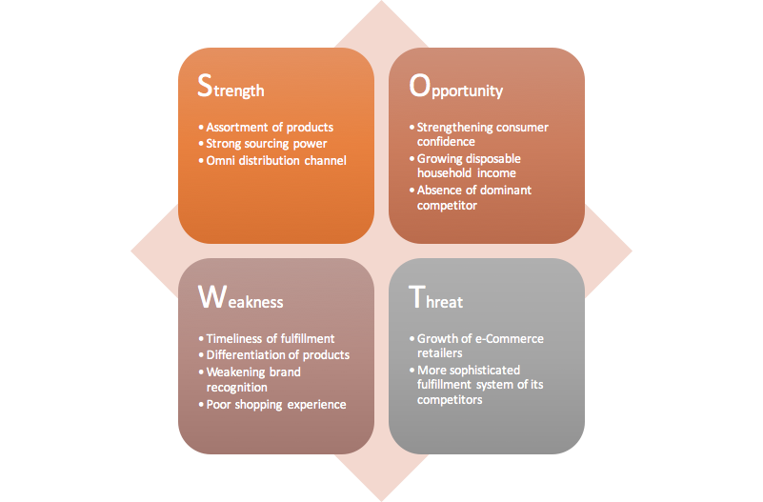

Figure 3.6 SWOT

While Macy’s is confronting a series of issues and the critical contributing factors have been revealed above, a more comprehensive review of Macy’s position is analyzed and presented as SWOT analyses below.

From another standpoint, Macy’s has to embrace the threats along with the opportunities. On account of the technology, a lot of online shops has emerged and intensify the competitions. Without the cost of store footage, these online shops can scale up quickly at minimum incremental cost.

On the other hand, the most sophisticated fulfillment system of Amazon is always the greatest threat to Macy’s. Macy's needs to find a way to compete with it in a long run.

While the competition in retail industry is intensive, there is positive outlook for the market. First of all, the consumer confidence has reached historical peak, a strong rebounce since the 2008

credit crisis. Corresponding to that, it is reported the household disposable income continuously increased over years, which means US person now have more to spend.

It is important to note that there has not been a dominant player yet in the new era of retail. Amazon is expanding aggressively, yet they have not have proven track record in apparel and footwear. Nordstroms, JCPenny, TJMax are all trying to catch up with the new trend, whereas none of them have dominant market shares.

**Threat**

**Opportunity**

There is no doubt on the legacy of Macy’s success and its proven supply chain. By far, Macy’s is still the most powerful department store offering assortments of products. Customers can find most of the items they need in Macy’s for apparel, footwear and accessories. Women’s dresses, Men’s suits and a variety of shoes, cosmetics are available in Macy’s. It can be a one-stop shop for its customers.

Furthermore, it has broad access to nationwide customers through more than 800 stores, including major metropolitan areas and regional areas. With years of operations, Macy’s has built up a sophisticated supply chain , which enables it to source cost effectively from Asia. More than that, Macy’s online channel is picking up, slowly but progressively. This additional distribution channel opens up the gateway for Macy’s to younger generation and could brings a lot of growth potentials for it.

**Weakness**

One of apparent weakness of Macy’s is the timeliness of its online fulfillment. Starting late, Macy’s has been lagging in improving its logistics system. This turns out a significant drawback when compared with Amazon. While Amazon is offering two day delivery, Macy’s is only offering 3 to 6 business day for standard delivery. Despite the heavy investment on e-Commerce in the past 2 year, Macy’s still have a lot to do in this regard.

Second of all, not being able to offer differentiated products is a critical shortcoming. Macy’s customers can find substitutes easily and more affordable elsewhere. It will be of importance for Macy’s to seek for improvement on this aspect.

Lastly, poor shopping experience and weakening brand recognition also hinder the growth of Macy’s.

SWOT Analysis

**Strength**

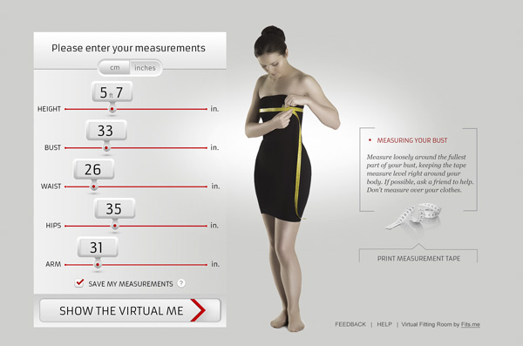

PHASE 3 Ferchil es eum experum, ulpa doluptat USD100,000

***Sam es dollanditis dolut harcia*** exceprovit laboriatur aut asintiunt

Customers making their way to online retailers have more than a few demands and expectations, and one of them is the ability to return ill-fitting garments in a fee- and hassle-free way.

This is an bother for both the customers and Macy’s. Hereby we introduce the Macy’s Show.

Customers could view runway styles either on-site at the Macy’s shop, online at the Macy’s website, or through the mobile app to be able to tap the product, virtually try it on, share it with friends and purchase it.

Customers can create their personal virtual image in order to browse products online, in print or in store and via technology is able to see how it looks and fits on their actual body. The item can then be mixed and matched with fashions from different retailers in their virtual closet, shared with friends or purchased through a link in the app.

When creating virtual image, the utmost priority is about data. There are two ways we may consider helping customer create their own virtual image.

The first one is let customer “make” their own image by providing some parameters tuning, such as height, waist, bust, hips, etc. In this way, the users are free to create what’s most similar with their own image. And Macy’s don’t need to bother collecting all of the data from customers.

Another way of collecting data and create virtual image is offline Smart AR mirror which will be elaborated in later section. When customers are using AR mirror inside Macy’s brick and mortar shop, their image are created by AR Mirror and then synchronized with their account.

By showing their virtual image to customers, we’re creating a new shopping experience by making both online and in-store shopping fun, social, simple and risk-free.

Online: Macy’s Show (Virtual fitting room)

STRATEGY

***Macy*s Inc.***

**HUNT SVILLE**

22

23

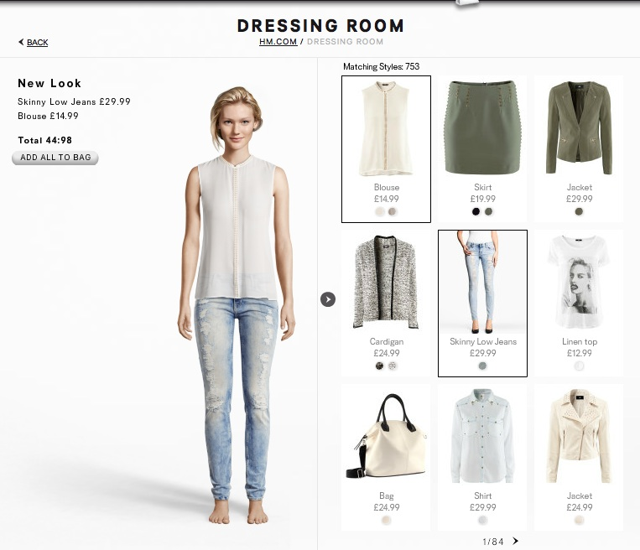s

Firgure 4.1 Creating personal vitual image

Figure 4.2 Try garments and accessories with vitural image

24

25

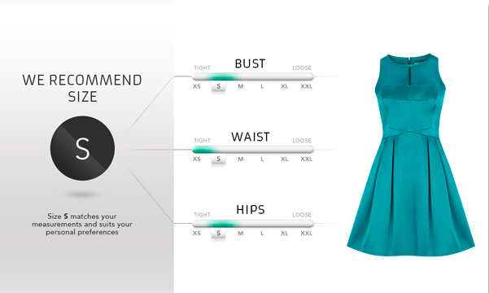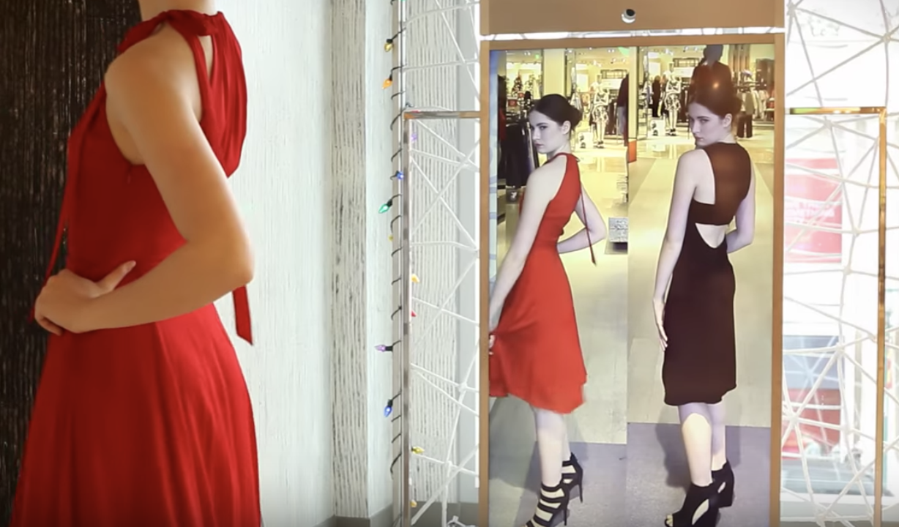

A step forward: Machine Learning Based Production recommendation.

Firgure 4.4 personal recommendation based on big data

So, here is Macy’s Show come into play.

Based on the historical data, the system can make precise recommendation which dramatically boost the conversion rate. Say one customer like dress very much (because she tried lots of dress in Macy’s Show System), then we can recommend more fashionable dress for her.

Macy’s show not only enable a well-fit and fun shopping experience, yet the more important part of this strategy is to accumulate customer’s data. As more and more customers create their own virtual image, most identical to their real data, Macy’s can make use of these data for more precise personal recommendation for each customer. This kind of data is known as the strength of online retailer.

Macy’s, as a giant brick-and-mortar chain retailer, has outstanding advantage in terms of supply chain and product management. What may empower it is how to map countless product to the most likely buyers (customers).

Firgure 4.3 Smart AR Vistural Mirror help rrying different garments

Offline: Smart AR Mirror

Any consumers consider trying on clothing an inconvenient and time-consuming aspect of the retail experience. They might feel overwhelmed by the many clothing options to circle through, or feel awkward about asking a sales attendant for a room. Some might be simply too lazy to take off their shoes. Regardless, many people do not want to go into fitting rooms.

A smart mirror or virtual fitting room enables customer to virtually dress their reflection and it should allow shoppers to paste online clothing onto their mirror image and to look at themselves at every angle. The smart mirror has a built-in camera that consumers can use to take pictures of themselves and their outfits. These can be shown to friends, other users or virtual stylists, but users can also add a new background, like a tropical beach.

Here’s the breakdown of each customer’s experience:

* The device followed a person’s movements, scanned their face and took a picture of them.
* On an big screen, customer could control their look by changing their outfit including jackets, jumpers, trousers.
* The new look was saved and sent to the user via email where they could share it on their Facebook as well. All historical data will be synchronized to their own account for future reviews.

We wants to expand this mixture of photo and virtual reality with augmented reality in a way that allows users to virtually adjust clothing. The filed smart mirror patent is a combination of cameras, lighting and advanced tracking software.

OVERVIEW

26

27

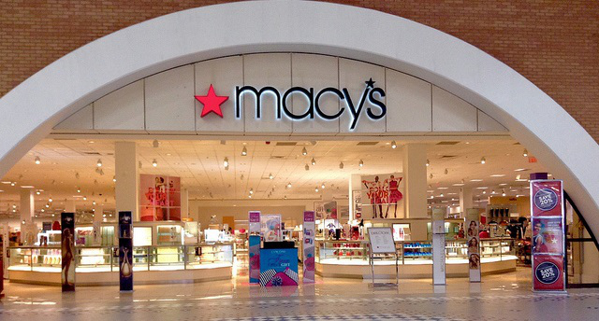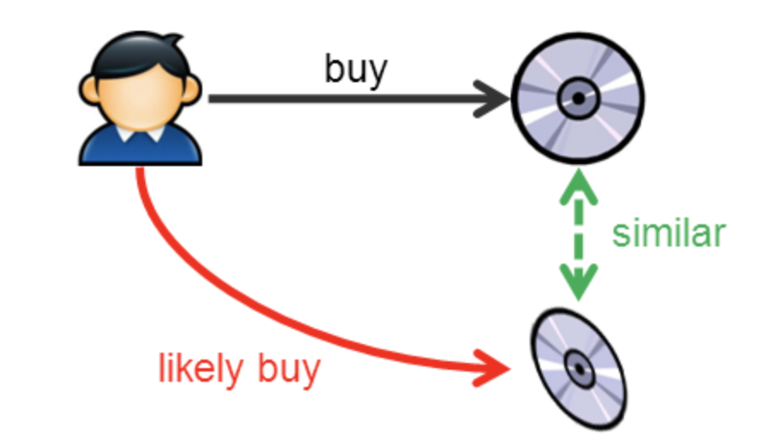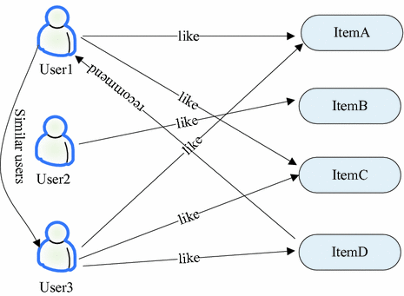

Up: Firgure 4.5 User based collabortive filtering

Down: Figure 4.6 Item based collabortive filtering

**Macy’s show**

This solution can put Macy’s in an advanced position of the retail trend. As the consultant report stated, the main issue of clothing shopping online is that the client cannot try the cloth in real, so the sophisticated feeling of the material, garment and style is ambiguous compared to try on real physically. This is because the lack of high-level detail combination of the clothing and the clients. This used to be solved in 2D by simply uploading the pictures and overlapping each other. However, this is far more than the real-world feeling visually and physically.

The fitting experiences this system provided is the constructed by voxelization high-revolution digital model in 3D body measurements. This system will use 3D body scanner to obtain very detail measurements of all the body parts of the clients, instead of just hip, neck, shoulder and etc. that the traditional tailors will measure. Then, transferring these data into the scanner software to model and re-build a 3D body model in small scale but same body ratio. So client can see their own body online with different clothes they picked up to try on.

With this solution, Macy’s can stand out apart from its competitors and stay ahead of the retail trend. boost its online shopping.

As analyzed in the previous chapter, Macy’s issues result from 3 critical causes.

Our solutions aim to tackle down three goals:

to keep up with the consumers’ behavioral change,

to provide unique experience,

to improve the brand recognition.

**3**causes

Reasons

STRATEGY

***Macy*s Inc.***



As a whole, Macy’s Show has the power to change the way traditional and digital marketing operates. Consumers will be more inclined to purchase from virtual fitting rooms because their retail experience is fun, easy and sociable.

The system has all of the date among all customers, therefore it know exactly what they bought. Based on this data, say if user 3 had bought Item A, C, D and user 1 bought Item A, C, then it’s very likely that user1 will also want to buy Item D because user 1 and user 3 are similar in terms of shopping preferences. So, if user 3 like Item D, there is high chances that user 1 will buy it as well.

In regard of recommendation algorithm, here are two alternatives that will be practical in commercial usage with appropriate fine tuning.

The first algorithm is User-based collaborative filtering, as shown below.

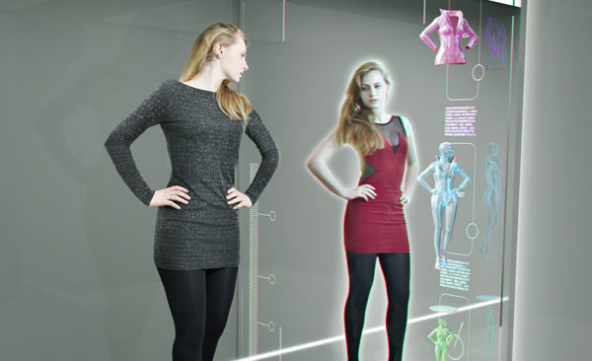

*Customer data collection*

For customer data collection, we have online and offline strategies. For online strategy, personal account for our customers. First, we have E-sign agreement with customers to protect their personal data safe. Second, once customers put in some their basic personal information, such as weight and height. Third, Our system will generate predicted detailed data such as, chest circumference, waistband, opening circumference, according to those basic information. Customers need make a little bit change based on their body shape and confirm the data. For offline strategy. We will have 3d body scanner at Macy’s department store. Customers are able to utilize 3d body scanner to get their data. Those 3d body scanners will be installed in department store belong to Macy’s, such as Macy's, Bloomingdale's and Bluemercury. 3d body scanners will be only used in certain city. Such as, New York and Los Angeles. If our entire system works well, we will consider spread out our 3d body scanners equipment to nationwide Macy’s department store. Same as online data collection, we will need customer confirm their personal data and E-sign agreement. When data collection completed, customer’s personal data will be saved on Macy’s database for later analysis and computing. Data collection is not just a one time work, customer can update their personal data in any time.

**Macy’s System Building**

Macy's new CMO Richard Lennox announced, Macy's media will shift from 30-second national TV spots to 15-second local TV ads. Instead of running sporadic promotions, Macy's will focus on four annual tentpole events based on the seasons.  As 159-year-old department store, this marketing strategy is great to retain older, loyal customers. However for attracting newer, young consumers, those marketing strategies may not be attractive. Our marketing strategies are utilizing social medias, suc Macy’s system building h as facebook and snapshot to promote and advertise “Macy’s show”. Meanwhile, we will participate some events for younger generation. Such as comic con, some campus events. We will exhibit our 3D body scanner and let people try to our equipments to get our customers’ personal data. According to the data that we collected, system will generate virtual model with this customer’s body size. Customer is able to use smartphone application to see the clothes that he or she put it on and change the clothes as much as he or she wants. Once this customer finds any clothes he or she likes, customer only needs to move the finger to buy it or save it for later comparing. Also customer is able to see effect when he or she put on the clothes on the digital virtual dressing mirror.

**AR Mirror**

STRATEGY

***Macy*s Inc.***

Implementation

**Enhanced Branding**

Through offering these new technology features, Macy’s is able to elevate its branding among younger generations, who are its primary target customers. With these technologies, Macy’s differentiates itself from traditional department stores.

Currently, there has not been a single department store offering these technologies. Leveraging technology is in line with younger generation’s preferences and increases its brand recognitions amongst its target customers. In the long run, the enhanced brand recognition can be capitalized and bring innumerous profits.

**AR Mirror**

Another cause of Macy’s issue - incapability to provide unique shopping experience, will be solved by the AR Mirror solution. As analyzed in the previous chapter, consumers nowadays are looking for experience beyond ordinary.

It’s often complained that there is a long line for the fitting room or customers having difficulty locating the item with their desired size. Such complaints are very common but rarely considered and solved in traditional department stores. By providing the AR mirrors, Macy’s is providing an unique and better shopping experience to its customers. With it, customers no longer need to wait for long in order to try something out. They can also save the time in the fitting room since they can immediately see the visual effect when the item is “on” them.

On the other hand, customers can more easily change the size or color of the item in the mirror, which save their time looking through the racks to find the size or color they want. By offering these benefit, AR Mirror improve customers’ shopping experience significantly.

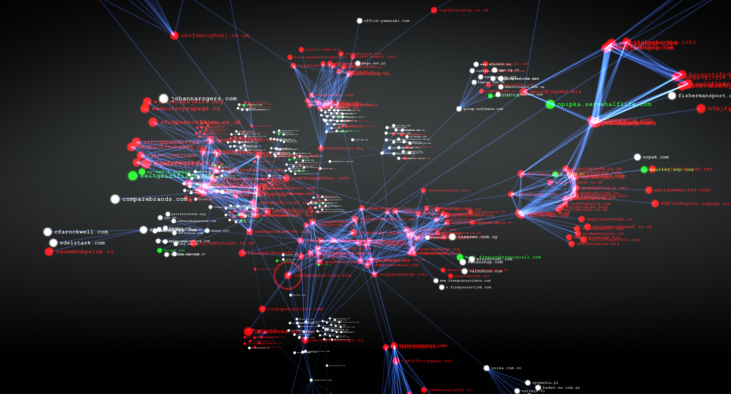

*Data analysis*

when customer’s data has been collected. On the customer side. There will be body model generated on customer’s phone application or personal computer, according to customer’s personal data. Customers are able to put on any clothes that they like on this body model to see the if the cloth fits or not. When customers are playing with body model, backend server is collecting clothing data at same time. Those data will be used to train the model in our machine learning system. Based on the well trained model, system will recommend the clothing for customer, according to customers’ preference. Also, macy’s system is able to utilize big data that have be collected to catch the fashion trend to enhance sourcing department.

*High tech equipment supplement*

In Macy’s department store, we will install high tech equipment as supplement. such as digital virtual dressing mirror. Customers may meet some situations. For example, they like certain clothes’ style, however, current department store don’t have this color. On the digital virtual dressing mirror, it will exhibit clothes with the color customer want. As long as customer want to them, Macy’s will mail to them. Also, digital virtual dressing mirror contains facial recognition system. Therefore, customers only have to face the mirror. The mirror will recognize customer and start loading data for customers. When digital virtual dressing mirror completed loading data, customers are able to drag any saved clothes and clothes that current department store offered to make sure those two clothes are looking good when put on both of them on. Any clothes that showed on the digital virtual dressing mirror can be saved to online personal account. Digital virtual dressing mirror will enhance online and offline connection. With the online and offline connection, customer personal online account can turn to be a portable wardrobe. In department store, they can easily utilize the mirror for shopping.

BREAKDOWN

28

29

TIMELINE

30

31

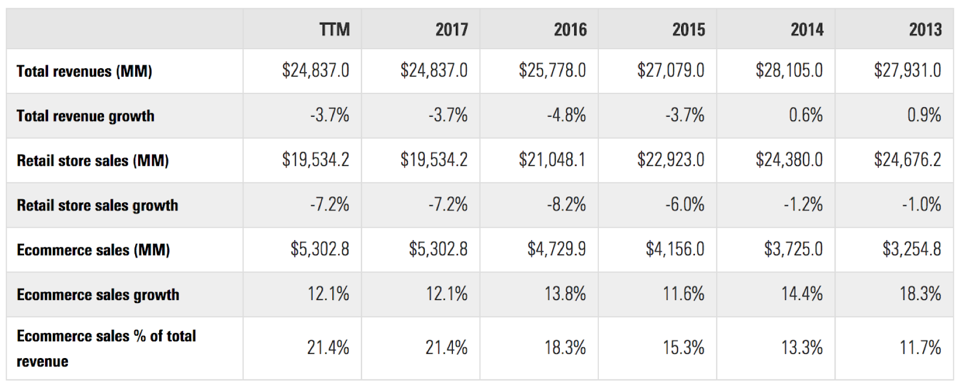s

Lteft Up: Table 6.1 Cost analysis for system

Left Down: Table 6.2 E-commerce sales of Macy*s quarterly in the latest financial year

Right: Table 6.3 Return on Investment

This table indicate the return on investment on this system, which is about 15.88% in the first year.

RETURN ON INVESTMENT

***Macy*s Inc.***

|  |  |  |
| --- | --- | --- |
| ***Gain on the Investment (MM)*** | **Cost of investment (MM)** | **ROI** |
| *15.196021848* | 0.9 | **15.88446872** |

From the ecommerce sales growth from 2013 to 2017, this strategy estimates the growth on 2018 is the same as the average growth, 13.71%. This is about 6030.16 MM USD. As the suppliers of 3D Body Scanner stated, the digital technology will boot the sales about 3%, about 180.91 MM USD. The Profit is 116 MM.

As shown in the table above, the estimated total cost for 19 flagship stores is about 0.9 MM (million) USD for both of the 3D Body Scanner and Digital Virtual Mirror.

During the booting in retailing industries over couple decays, Macy*s covers most first-tier and second-tier city over the United States, and constructs 19 flagship stores which provided the highest revenue and attract most amount of consumer’s attention. This strategy plans to distribute both of 3D virtual digital mirror and 3D body scanner in each flag stores.

|  |  |  |  |
| --- | --- | --- | --- |
| ***Price*** | **3D Body Scanner (K USD)** | **Digital Mirror (K USD)** | **Total (K USD)** |
| *Each Flag Store* | 40 | 6.4 | 46.4 |
| *Total 19 Flag Store* | 760 | 121.6 | 881.6 |

“The Best 3D Body Scanners in 2018 (3D Body Scanning).” *Aniwaa*, [www.aniwaa.com/best-3d-body-scanners/](http://www.aniwaa.com/best-3d-body-scanners/).

Halzack, Sarah. “Macy's Needs to Sharpen Its Fuzzy E-Commerce Strategy.” *Bloomberg.com*, Bloomberg, 9 Nov. 2017, [www.bloomberg.com/gadfly/articles/2017-11-09/macy-s-needs-to-sharpen-its-fuzzy-e-commerce-strategy](http://www.bloomberg.com/gadfly/articles/2017-11-09/macy-s-needs-to-sharpen-its-fuzzy-e-commerce-strategy).

“Macy's | Revenues & Sales.” *EMarketer Retail*, retail-index.emarketer.com/company/data/5374f24c4d4afd2bb44465c7/5374f29b4d4afd824cc15c53/lfy/false/macys-revenues-sales.

“How Nordstrom Underpins The Shopper Experience With Data.” *PSFK*, 24 Dec. 2017, [www.psfk.com/2017/12/nordstrom-underpins-the-shopper-experience-with-data.html](http://www.psfk.com/2017/12/nordstrom-underpins-the-shopper-experience-with-data.html).

Baird, Nikki. “A Cautious Future For Department Stores In 2018.” *Forbes*, Forbes Magazine, 30 Jan. 2018, [www.forbes.com/sites/nikkibaird/2018/01/30/a-cautious-future-for-department-stores-in-2018/#62170fa68c9a](http://www.forbes.com/sites/nikkibaird/2018/01/30/a-cautious-future-for-department-stores-in-2018/#62170fa68c9a).

Penn, Sharon. “Difference Between a Department Store & a Chain Store.” *Small Business - Chron.com*, Chron.com, 21 Nov. 2017, smallbusiness.chron.com/difference-between-department-store-chain-store-24127.html.

“Macy's.” *Wikipedia*, Wikimedia Foundation, 26 Apr. 2018, en.wikipedia.org/wiki/Macy's.

NetSuite.com. “Do You Know What ERP Is? Learn How ERP Can Help Your Business with This Informative Article.” *NetSuite.com*, [www.netsuite.com/portal/resource/articles/erp/what-is-erp.shtml](http://www.netsuite.com/portal/resource/articles/erp/what-is-erp.shtml).

“3D Kinect Virtual Dressing Mirror Virtual Fitting Room 42inches-in Decorative Mirrors from Home & Garden on Aliexpress.com | Alibaba Group.” *Aliexpress.com*, [www.aliexpress.com/item/3D-Kinect-Virtual-Dressing-Mirror-Virtual-Fitting-Room-42inches/956281641.html](http://www.aliexpress.com/item/3D-Kinect-Virtual-Dressing-Mirror-Virtual-Fitting-Room-42inches/956281641.html).

McKevitt, Jennifer. “Macy's RFID Effort Boosts Sales, Fulfillment.” *Supply Chain Dive*, 20 Apr. 2017, [www.supplychaindive.com/news/RFID-Macys-success-inventory-fulfillment-markdown-Platt/440827/](http://www.supplychaindive.com/news/RFID-Macys-success-inventory-fulfillment-markdown-Platt/440827/).

“Why 2017 Will See Desperate Department Stores and Anxious Apparel Chains.” *Fortune*, fortune.com/2017/01/03/why-2017-will-see-desperate-department-stores-and-anxious-apparel-chains/.

Keyes, Daniel. “Amazon Could Lead US Apparel Retail by the End of This Year.” *Business Insider*, Business Insider, 24 Apr. 2018, [www.businessinsider.com/amazon-lead-us-apparel-retail-2018-4?r=UK&IR=T](http://www.businessinsider.com/amazon-lead-us-apparel-retail-2018-4?r=UK&IR=T).

Bailis, Rochelle. “Nordstrom vs. Macy's: a Department Store Showdown.” *Digital Commerce 360*, 24 Dec. 2017, [www.digitalcommerce360.com/2017/02/16/nordstrom-vs-macys-department-store-showdown/](http://www.digitalcommerce360.com/2017/02/16/nordstrom-vs-macys-department-store-showdown/).

“How Fashion Retailer Nordstrom Drives Innovation With Big Data Experiments.” *Datafloq - Connecting Data and People*, datafloq.com/read/how-fashion-retailer-nordstrom-drives-with-innovat/398.

Wolfson, Rachel. “Retailers Using Big Data: The Secret Behind Amazon and Nordstrom's Success.” *Big Data News*, [www.bigdatanews.datasciencecentral.com/profiles/blogs/retailers-using-big-data-the-secret-behind-amazon-and-nordstrom-s](http://www.bigdatanews.datasciencecentral.com/profiles/blogs/retailers-using-big-data-the-secret-behind-amazon-and-nordstrom-s).

Eturios el idusae. Nam, as num eicipsusanti te suntia ab incto berupta vendis repedis ipsunt volorum iur. Assitiam, voluptatur sequi auta sus reium velluptaqui ipitatu riostest est quatem eum quibus exceaque ipsa consequatem cuscieniae volorem. Ditam dolut minctem et alia si as que dolorro rerchitae idendunt dem eos pos nonecullam eatur sitatibus.

Grosman, Lin. “The Future Of Retail: How We'll Be Shopping In 10 Years.” *Forbes*, Forbes Magazine, 21 Sept. 2017, [www.forbes.com/sites/forbescommunicationscouncil/2017/06/20/the-future-of-retail-how-well-be-shopping-in-10-years/3/#f2192f853d5b](http://www.forbes.com/sites/forbescommunicationscouncil/2017/06/20/the-future-of-retail-how-well-be-shopping-in-10-years/3/#f2192f853d5b).

Gustafson, Krystina. “Amazon Actually Isn't the Biggest Problem, Macy's CFO Says.” *CNBC*, CNBC, 8 Mar. 2017, www.cnbc.com/2017/03/08/macys-cfo-department-stores-face-a-threat-bigger-than-online-shopping.html.

Kirkpatrick, David. “Will a Tactical Marketing Strategy See Turnaround for Macy's?” *Marketing Dive*, 8 June 2017, [www.marketingdive.com/news/will-a-tactical-marketing-strategy-see-turnaround-for-macys/444520/](http://www.marketingdive.com/news/will-a-tactical-marketing-strategy-see-turnaround-for-macys/444520/).

“Macy's Is Bracing for Another Bad Year.” *Fortune*, fortune.com/2017/02/21/macys-results-decline/.

Bhattarai, Abha. “'The Unfortunate Thing about Macy's': Just about Everything.” *The Washington Post*, WP Company, 11 May 2017, [www.washingtonpost.com/news/business/wp/2017/05/11/the-unfortunate-thing-about-macys-just-about-everything/?noredirect=on&utm_term=.d543c602f029](http://www.washingtonpost.com/news/business/wp/2017/05/11/the-unfortunate-thing-about-macys-just-about-everything/?noredirect=on&utm_term=.d543c602f029).

**REFERENCE**

QUOTATION

200$/sqm

Feribus solorectem eaqui aliquae esti temos doluptat

1,000 SQM

200,000

Ximus dolupta que comnis num evellab ini coribeatur

1,000 SQM

200$/sqm

200,000

Inuscien demque nonsequis vent, quas si iunt moluptas

1,000 SQM

200$/sqm

200,000

Ulpa dolorest alit hiliqua tiaspiet solorist arum asam

1,000 SQM

200$/sqm

200,000

Peris rem rerferum recta voles et reperumet quae

1,000 SQM

200$/sqm

200,000

Nim faccat voluptat ut que antiis et lanim a ersperum

1,000 SQM

200$/sqm

200,000

Caborum lam et sae nimusanis aspiendis mil ipsanienit lab

1,000 SQM

200$/sqm

200,000

Sintemporerro cus magnam nos dicae moditat iaeratq

1,000 SQM

200$/sqm

200,000

Occatur quuntio endit fugitiisin nonserrovid ea voluptatus

1,000 SQM

200$/sqm

200,000

Namus soluptaque ommolor eperferibus volenempos

1,000 SQM

200$/sqm

200,000

Cerum remporemquo omniaer chilisto ent officil mo

1,000 SQM

200$/sqm

200,000

1,000 SQM

Pedis sequi cuptatemque ped et illa pre maionseque vellab

200$/sqm

200,000

Tur? Me ium int aspera volupta tatium fuga qui inullab

1,000 SQM

200$/sqm

200,000

1,000 SQM

200$/sqm

200,000

Et asperum eatio cum retet aceperci blanimet lab ilit

Bus re quatur ficiento berume sam inihita tendit vendi rae

1,000 SQM

200$/sqm

200,000

Tat sape molorate voluptatecte est voluptae omnis sapellu

200,000

1,000 SQM

200$/sqm

***TOTAL***

***$20.000.000USD***

DATE:

/ /

NAME:

PLACE:

SIGNATURE:

32

33